# Lab – Data Analysis and Data Modeling in Visio

## Overview

In this lab, we will learn to draw with Microsoft Visio the ERD’s we created in class.

### Learning Objectives

Upon completion of this learning unit you should be able to:

* Understand the concept of data modeling
* Develop business rules
* Develop and apply good data naming conventions
* Construct simple data models using Entity Relationship Diagrams (ERDs)
* Develop entity relationships and define various types of attributes

### Lab Goals

Our lab goals are to:

1. Learn to build conceptual models in Microsoft Visio.
2. Create the 1 ERD in the Part 2 below and the 3 ERDs from class in Microsoft Visio. You will only turn in Exercise 3 for grading. Note to do so you must save it in PDF format (figure that out).

You will have to hand in all 5 diagrams as one VISIO file in Blackboard.

### What you will need to begin

1. A copy of **Microsoft Visio 2016**
2. The class exercises from this week (should also be with the other files from week’s lesson.)

## Part 1: Getting Ready for Using Microsoft Visio for Conceptual Modeling

### Overview

This section will explain how to use Microsoft Visio to create conceptual Entity-Relationship data models. Microsoft Visio has built-in database tools for creating ***logical data models*** (those that apply the relational database theory to your entity-relationship diagrams), and not very good at conceptual modeling. As a result, using the MS Visio database tools to create the conceptual model diagrams can sometimes feel like trying to jam a round peg into a square hole.

Since not many people are into shoving round pegs into square holes, this guide will explain how you can maximize ***the Visio database tools*** for creating conceptual models. For those of you familiar with Visio, here are the heuristics we will follow to make Visio conceptual model friendly:

* Use Database Model Diagrams
* Modify the settings to be more user-friendly

### Step 1: Create New Document

After opening Visio 2016, the first step is to create a new document.

From the Visio template screen, choose “Crow’s Foot Database Notation.”

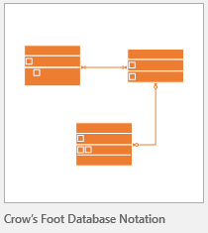

From the pop-up window, select “US Units” and click “Create”

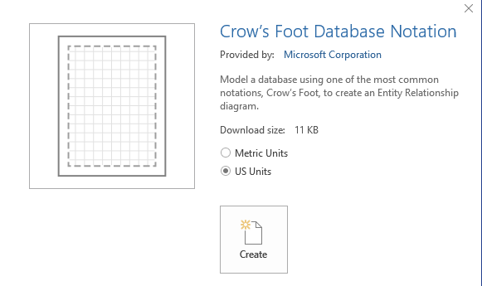

This will create your blank Visio page, and load the default database toolset.

**IMPORTANT:** The default Visio stencils are for ***logical*** modeling. I’ve created a custom stencil for conceptual modeling.

### Step 2: familiarize yourself with the shapes stencil

You should see the following on the left. This contains the shapes we will be using for the lab.

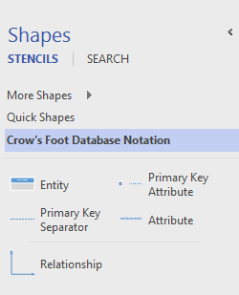

## Part 2: Microsoft Visio for Conceptual Modeling Walk-Thru

### Overview

In this section, we will walk-through creating a conceptual data model with Microsoft Visio. We will use the vBay! (E-bay “like” website case study as an example for conceptual modeling.)

### To Create an Entity:

Drag the C:\Users\jndaghir\AppData\Local\Microsoft\Windows\INetCache\Content.Word\2016-10-09 18_19_29-Drawing1 - Visio Professional.png icon onto the page and drop. Name the entity by double clicking “entity name”:

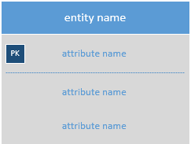

Because we do not indicate primary keys in conceptual modeling, we can erase the default one created. Click on the attribute to the right of “PK” and press the delete key. Your entity should look like this:

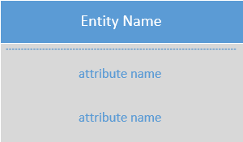

#### YOU DO IT:

**Now add these 4 Entities to your diagram:**

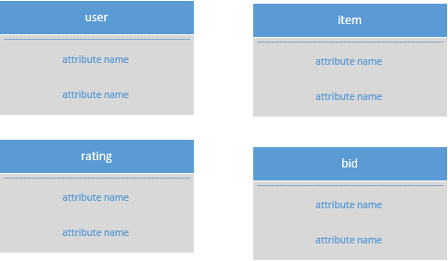

### To Add Attributes to the entity:

To add attributes to your entity, simply double click “attribute name” and enter in your column names. Be sure to include the appropriate **attribute descriptors [rucdm]** with the physical name. To add additional attributes to the entity, right click on one of the attributes and select “Insert ‘Attribute’ After.”

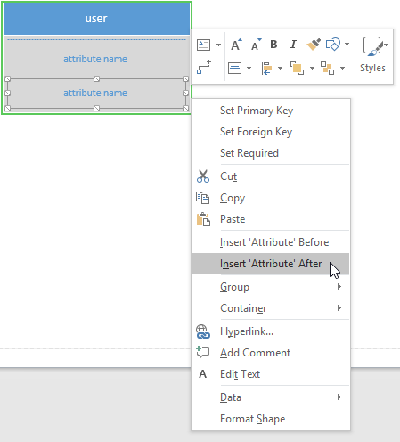

#### YOU DO IT:

**Now add attributes to all 4 entities, like this:**

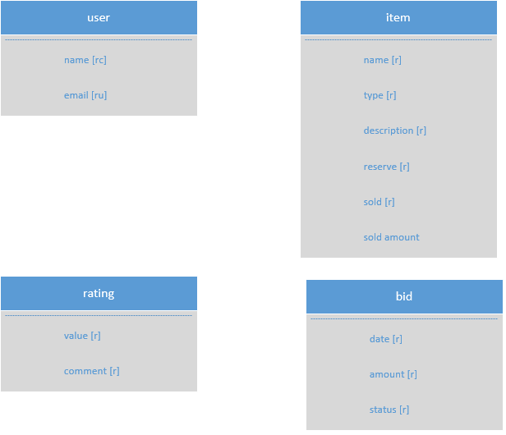

### To Add Relationships among the entities:

To Add Relationships, simply drag the relationship shape.  onto the page and connect the ends to each entity. To “snap” the line to the entity drag the line onto the box until it turns **green**, like this.

Green symbolizes the shapes are ***glued*** together**:**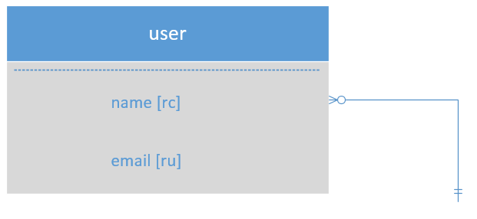

Click on the line and drag the other end to another entity to show the relationship between the two. You can **double-click** on the line to assign it a label. For example:

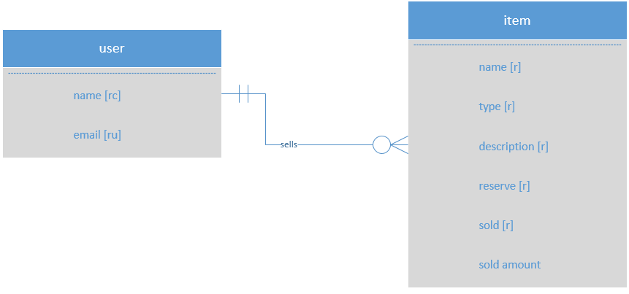

To change the cardinality right click on the connector and choose set begin symbol or set end symbol.

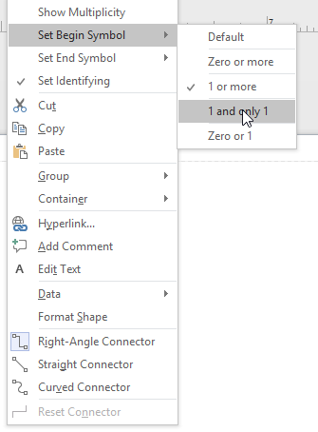

#### YOU DO IT:

**Now add all the relationships to complete the conceptual model, like this BUT YOU SHOULD NEVER SHOW TWO LINES FOR THE ENTITY as you see below. A Single line should say Rating By/For, or SELLS>BUYS:**

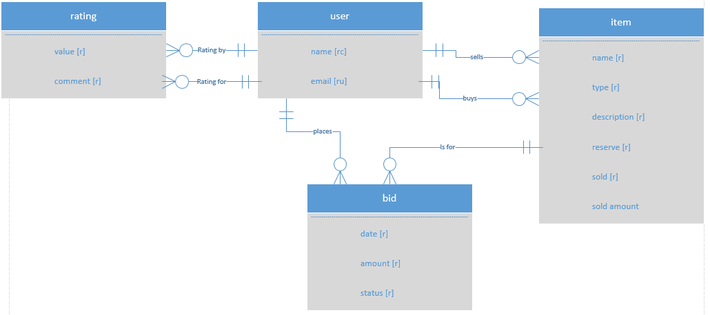

**Note:** You might have to juggle the shapes and lines around to achieve a best fit. It takes time and a whole lot of patience!

### Other Tips

**You can place multiple diagrams in one file!**

Just keep adding pages. To add a page, from the menu select: Insert 🡪 New Page, or click the plus button at the bottom of the window:

C:\Users\jndaghir\AppData\Local\Microsoft\Windows\INetCache\Content.Word\2016-10-09 19_08_29-Drawing1 - Visio Professional.png

To rename a page, right-click on the page and choose **Rename**

**You can add text to your diagram!**

Use the **Text** tool in the ribbon. Home 🡪 Text. When you’re finished, be sure to select the **Pointer Tool** again. 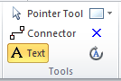

## Part 3: Creating the 4 diagrams from class exercise & handing it in.

Find the CLASS EXAMPLES EXCONMODELINGEXERCISES from class and draw them in Microsoft Visio.

* Place one diagram on each page.
* Label the pages accordingly
* Save the document in Visio format.
* Now save it in PDF format, extract only Page 3, save it as a PDF and upload the PDF!
* Upload the document to blackboard

**NOTE: You are only turning in Exercise 3. I deals with employees, projects, etc. If you do not turn it in in PDF format I cannot grade it and therefore you will not be able to earn any points for this lab! Note it is a 10pt lab week so please don’t forfeit the opportunity to earn all 10.**